

**Aug. 31st – Sept. 14th, 2024**

**Kyungpook National University, Korea**

**TRAINING REPORT**

**THE SHORT-TERM TRAINING COURSE ON**

**SOYBEAN BREEDING AND PROCESSING**

**TABLE OF CONTENTS**

**1. BACKGROUND**

**2. TRAINING OBJECTIVES**

**3. PARTICIPANTS**

**4. PROCEEDINGS**

**5. TRAINING EVALUATION**

**6. RECOMMENDATIONS**

**APPENDIXES**

1. **BACKGROUND**

The short-term training course on soybean breeding and processing under the project “Enhance the Production of Soybean and Create Innovative Technology for Processing and Utilizing Soybeans in Lao PDR and Vietnam” - Mekong-Republic of Korea cooperation Fund 2024-2026 was held at Kyungpook National University (KNU), Deagu, KOREA from August 31st – September 14th, 2024.

The purpose of the training course was to train pariticipants on the soybean breeding and production, and processing products from soybean. Training on soybean breeding and production included topics such as selection by DNA markers, phenotype selection, testing agronomic characteristics in the field, harvesting. Training on food processing included topics soy-milk, tofu, fermented foods, soy-snack, soy-cookies.

1. **TRAINING OBJECTIVES**

The objectives of the training course were as follows:

* Training on soybeen breeding and production
* Training on processing soybean for food.

1. **PARTICIPANTS**

The training participants included staff members of Agricultural Genetics Institute (AGI), Vietnam and National Agriculture and Forestry Research Institute (NAFRI), Lao.

Table 1. Participants’ list

|  |  |  |  |  |  |
| --- | --- | --- | --- | --- | --- |
| # | Name | Occupation | Organization | Contact | E-mail |
| 1 | Kim Khem | Researcher | NAFRI, Lao | +8562022458470 | hongphakdy@yahoo.com |
| 2 | Khamtay Vongxayya | Researcher | NAFRI, Lao | +8562097349669 | Khamtai.vsy@gmail.com |
| 3 | Pham Thi Bao Chung | Researcher | AGI, Vietnam | +84 988727166 | baochungagi@gmail.com |
| 4 | Le Thi Anh Hong | Researcher | AGI, Vietnam | +84 983122529 | anhhongagi@gmail.com |

1. **PROCEEDINGS**

* ***DAY 01: Attending Food exhibition***

The exhibition was held at EXCO, Daegu. There were many booths and companies with many products of agriculture, fishery, livestock and forest....

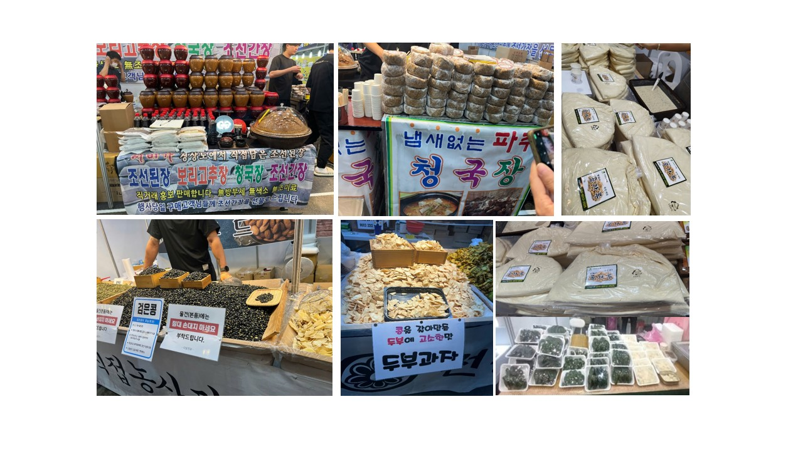

Picture 1. Soy-food products at the exhibition, EXCO

* ***DAY 02: Launching meeting Soybean breeding practice-DNA work***

Practicing on DNA work for soybean breeding with high omega 3 was held at the lab, KNU (Appendix 1. Protocol of DNA extraction).

Picture 2. Practicing on DNA work at the lab, KNU

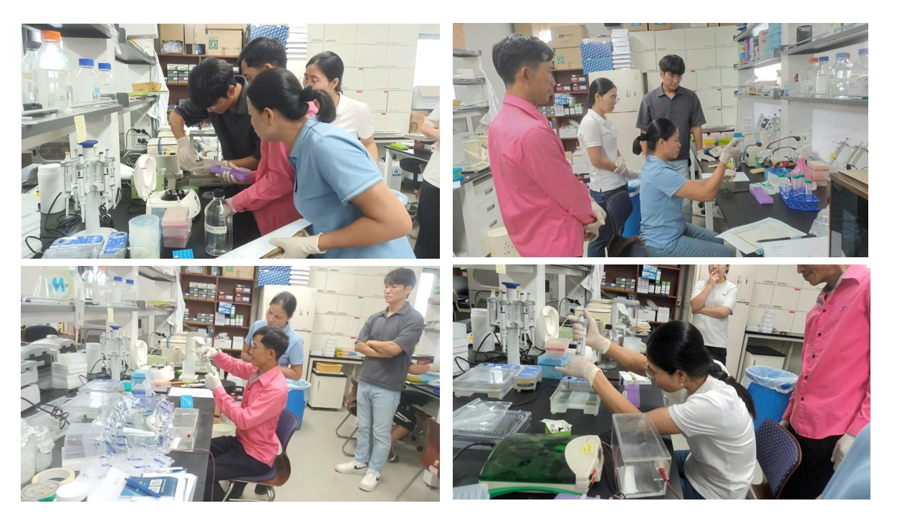

* ***DAY 03: Visiting Soybeen Breeding field and Research Institution***

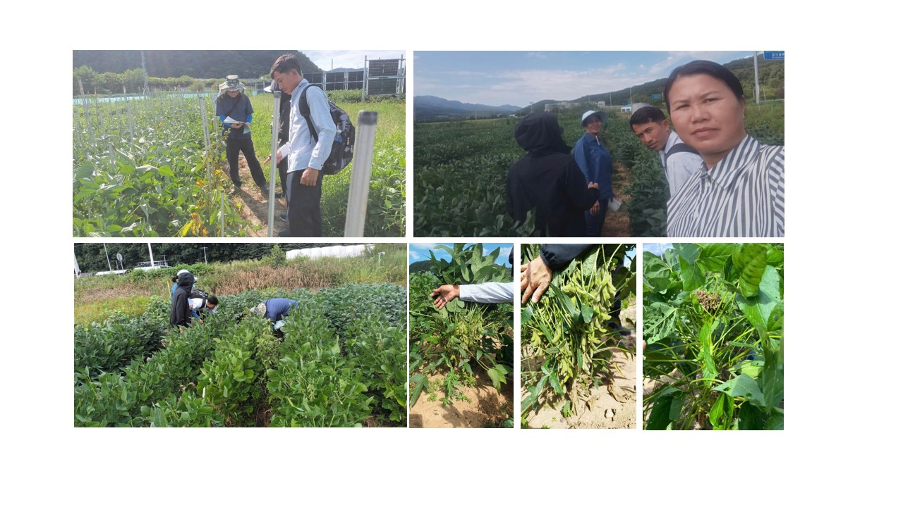

Picture 3. Visiting Soybean Breeding field, KNU

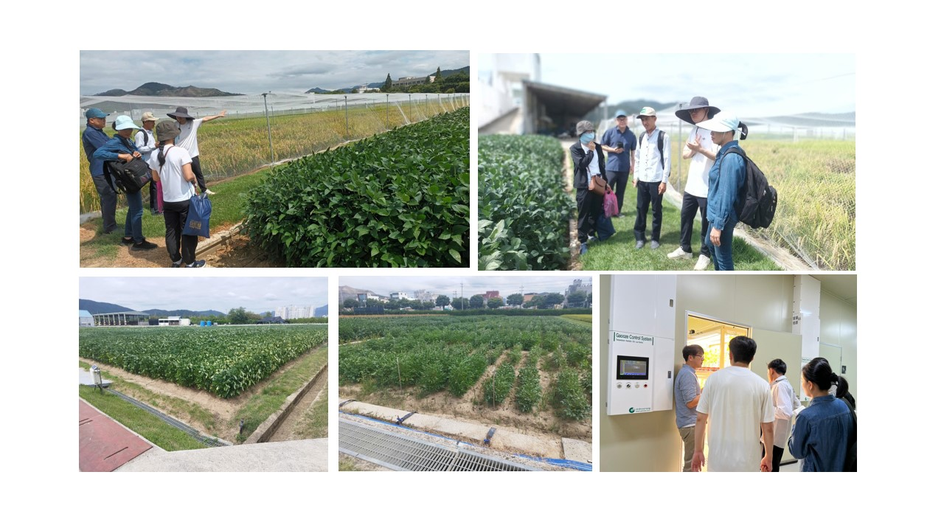

Picture 4. Visiting Rural Development Administration, Jeonbuk-do

* ***DAY 04: Making soy-foods: tofu, soy-milk***

Practicing on making tofu and soy-milk was done at the lab with a detail process (Appendix 2).

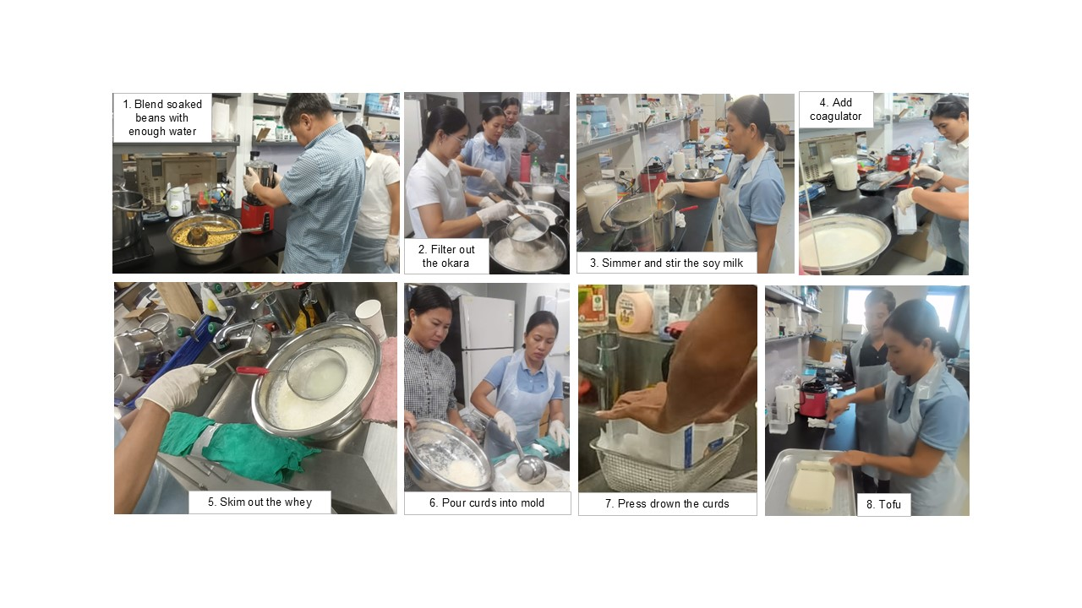

Picture 5. Steps of making tofu

* ***DAY 05: Makying soy-foods: fermented soy-foods***

Practicing on making natto was done at the lab with a detail process (Appendix 3)

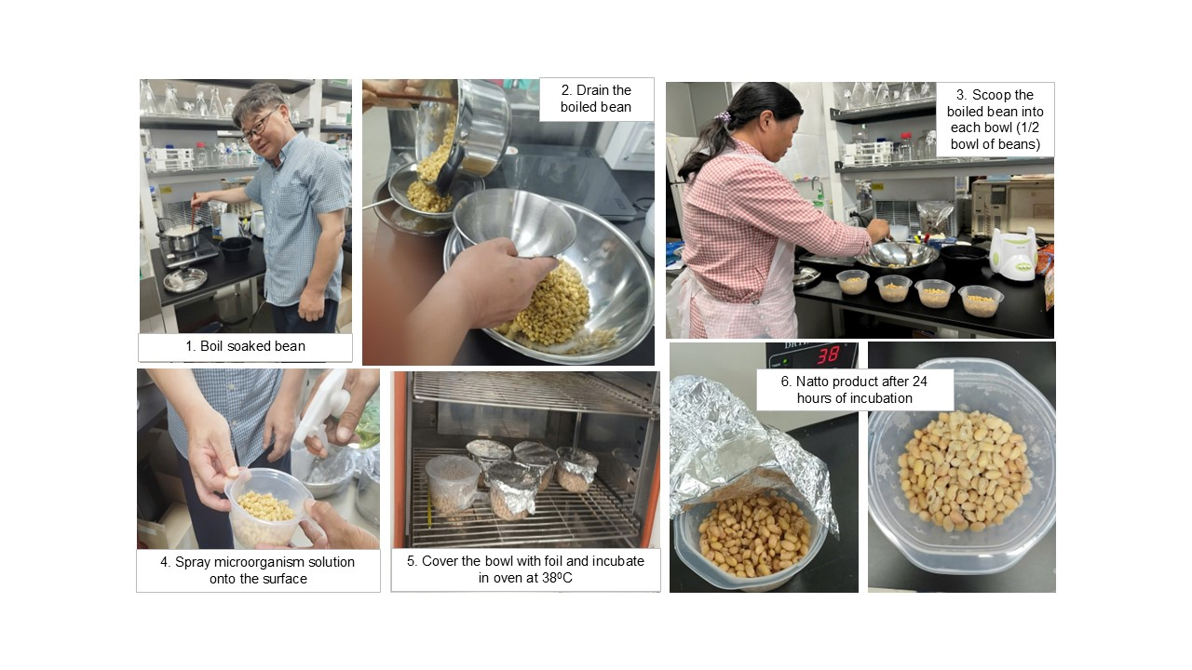

Picture 6. Steps of making natto

* ***DAY 06: Visting farmer’s field and model place for 6th Agri-Food industry***

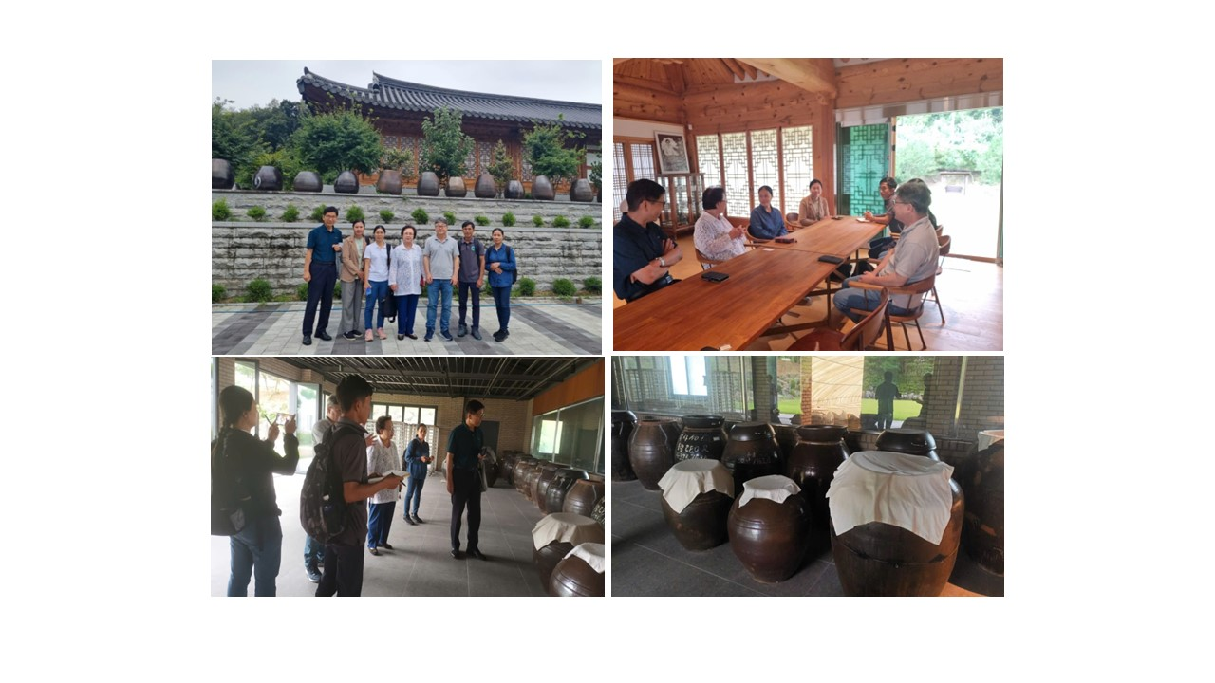

Picture 7. Visiting Korea Macgguroom Corp. for fermented soybean paste, Cheongsong

* ***DAY 07: Break***
* ***DAY 08: Doing homework: Investigation for soy-foods: world-wide***

(Appendix. 4)

* 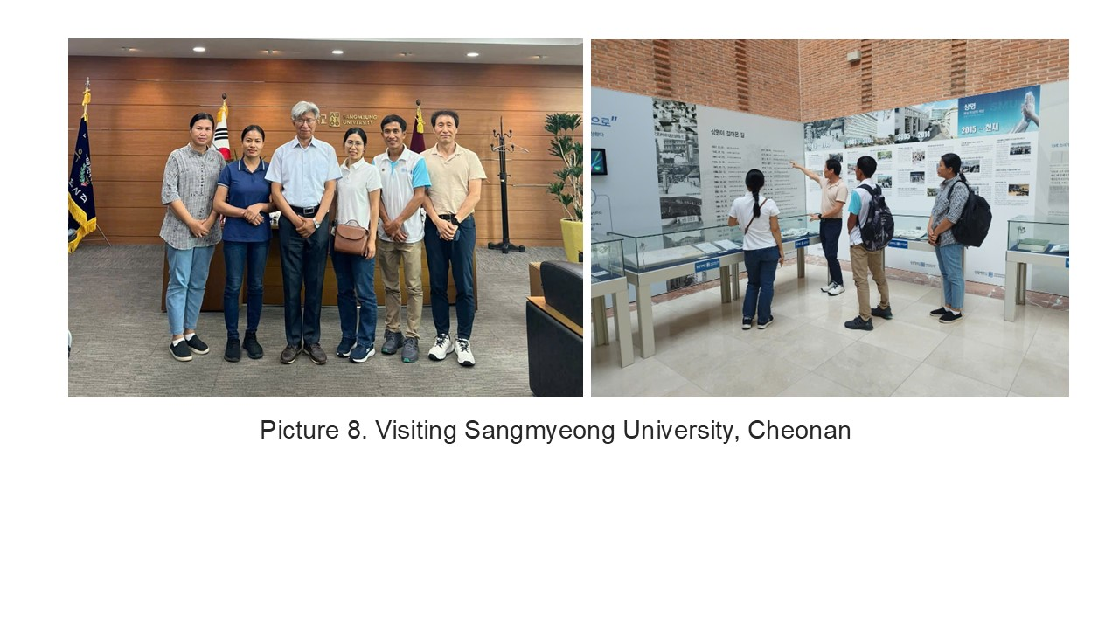***DAY 09: Visiting Sangmyeong University***
* A group of people standing in a line

  Description automatically generated***DAY 10: Visiting soy-milk company***
* ***DAY 11: Experience soybean food: visit big whole sale market and department store***

Picture 10. Soy-food products at the supermarket and department store

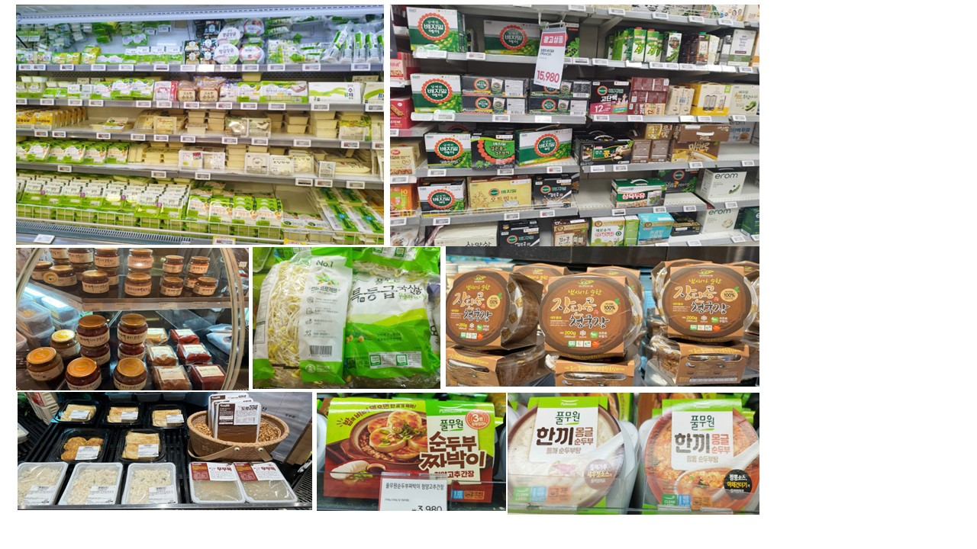

* ***DAY 12: Making soy-foods: soy-snack, cookies…***

Practicing on making tofu processed products was done at the lab with a detail process (Appendix 5)

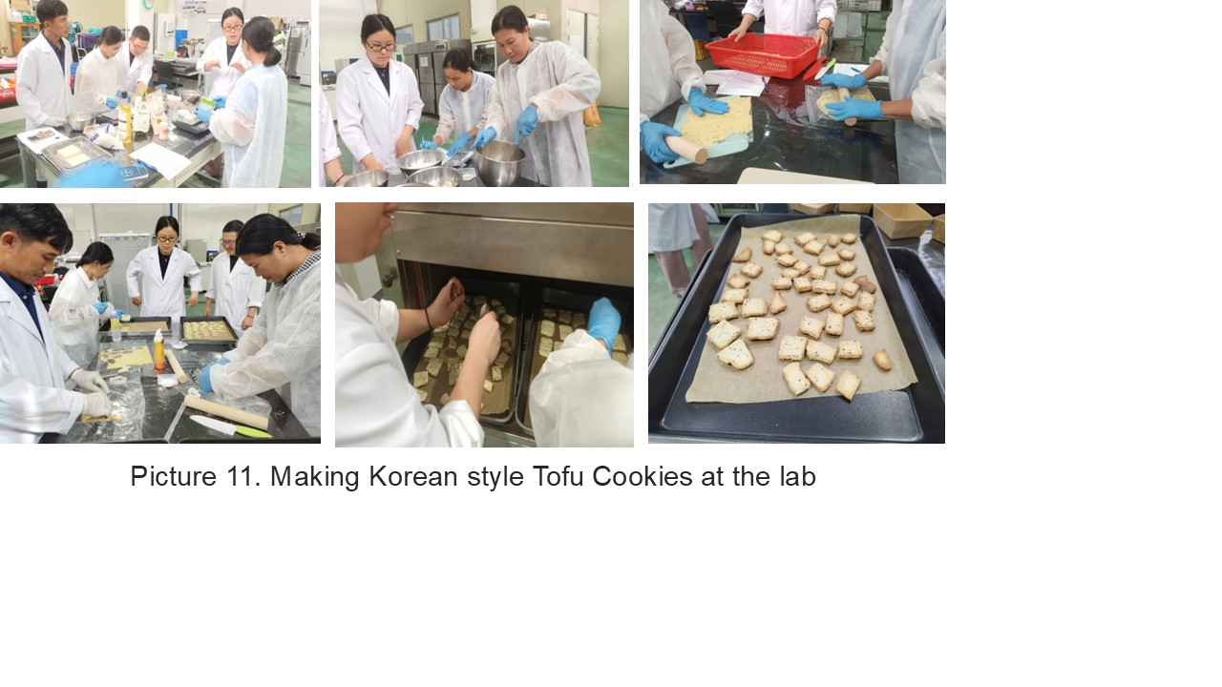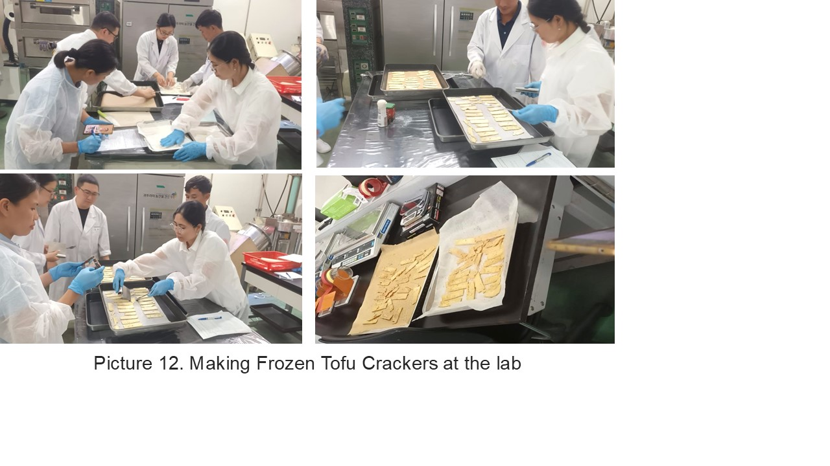

* ***DAY 13: Discussions and Suggestions***
* **In VIETNAM:**
* *Current status of soybean breeding and production, soybean processing:*

+ Soybean breeding: focusing mainly on the yield and short growth duration without paying attention to high oleic and linoleic.

+ Soybean production: Soybean production is still fragmented, poorly mechanized, labor-intensive which is difficult to attract farmers to participate in soybean cultivation.

+ Soybean products: There are many products from soybean such as tofu, soy milk, tofu pudding, Vietnamese traditional soy sauce, soybean powder, soy sauce, soybean oil, soybean sprout…of which, tofu is the most popular. It is present in the daily meals of people from rural to urban areas. However, tofu production has some disadvantages need to be improved. First is the low quality of soybean due to long storage time. Currently, more than 90% of soybean in Vietnam are imported from abroad. Domestic soybean production only meets about 8-10% of domestical consumption demand. In addition, existing soybean varieties are of low quality (low oleci and linoleic acid content, high okara ratio..). Second is the limitation of processing techniques (unsanitary production conditions, production steps are almost handmade or separately semi-automatic, packaging and package…).

* *Suggestions:*

+ Improving traditional soybean products through: tofu, soy milk

Applying new soybean varieties and new technical processes to increase domestical soybean productivity for supplying fresh soybean to processing.

Applying some new automatic machines to processing and packaging products.

+ Introducing some new soy products: soybean crackers, soybean cookies, soybean sprouts.

+ Improving soybean varieties with high oleic and linoleic acid for food processing:

Exchanging genetic resource with high oleic and linoleic acid;

Screening promising soybean lines and varieties with high oleic and linoleic acid under the support of KNU.

+ Improving soybean varieties with good quality for soybean sprouts: Exchanging genetic resource with good quality, 1000-seed weight less than 150g, black seed…

* **In LAO:**
* *Current status of soybean breeding and production, soybean processing:*

+ Soybean products:Most soybean products imported from Thailand.

Traditional soybean products in Laos: soy milk, tofu, Tofu pudding, and (fermented soybean paste in the northern part of Lao). But those products have low food hygiene and still normal packing and these products are produced in households and sold Day By Day at small markets in the village.

* *Disadvantages*:

+ Traditional variety, low yield, and some variety imported from Thailand and Vietnam…

+ Techniques: low food hygiene and safety conditions, normal package, separately semi-automatic (grind machine, squeezing machine, steamed machine).

* *Suggestions:*

+ Improving soybean varieties with high yield and high omega 3 through molecular markers for selection and resistance to insects & disease, and adapting to environments.

+ Improving traditional soybean products: Tofu, soy milk, soy snacks, and soy sauce. Try making Tofu, soy milk, and soy snacks (modifying the ingredients of the product that you want) and making packaging.

* ***DAY 14: Leave Korea***

1. **TRAINING EVALUATION**

With regards to training, it was very helpful and the content and exercises used in training helped us understand the activities and its significance. We found the training course was very helpful and easy to practice. Other factors such as time division and activities covered in during the training were under the dedicated guidance by Prof. Jeong-Dong Lee, Dr. Park, Dr. Jun-Hyun Oh and students.

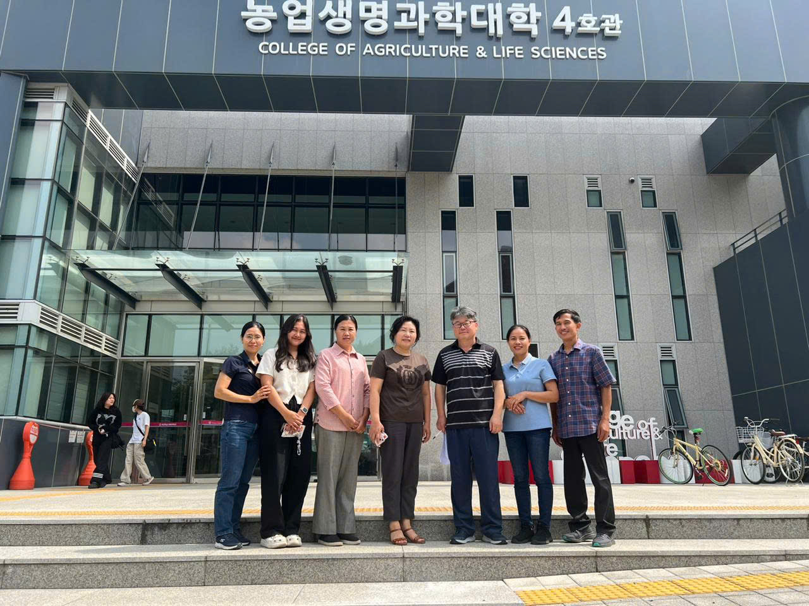

1. **RECOMMENDATIONS**

Booking flights at more convenient times of the day with checked baggage weight of 25-30kg.

**APPENDIXES**

**APPENDIX 1. PROTOCOL OF DNA EXTRACTION**

**Materials:**

Microfuge tubes

Small foreceps

LN2

Ball mill, and 4 mmdia ball bearings

Shorty extraction buffer

Ice bucket

100% isopropanol

70% ethanol

Sterile dH2O

**Method:**

1. Using small forceps take a small young leaf at the center of the rosette if possible, place in microfuge tube.
2. Add a small, 4 mm dia, stainless steel ball bearing to tube, close and store at -200C until ready to continue with DNA extraction.
3. Grind leaf material frozen (LN2) in ball mill for 30 seconds at a frequency of 30 (max)
4. Add 500 ul of shorty buffer, vortex to mix place on ice.
5. Centrifuge tube at maximum speed for 5 minutes.
6. Wear gloves for all subsequent steps to avoid contamination, pipette off 350 ul of supernatant and transfer it to a nea tube, discard old tube with pellet.
7. Add 350 ul of isopropanol to transferred supernatant.
8. Invert tube about 20 times to mix.
9. Centrifuge tube at maximum speed for 10 minutes.
10. Don’t worry if you can’t see the pellet, its ther, pour off supernatant, add 500 ul 70% EtOH.
11. Flick tubes or use up and down pepetting to resuspend pellet, only vortex if you have to
12. Centrifuge tubes at maximum speed at room temperature for 2 minutes.
13. Discard supernatants, and allow pellet to air dry for 10-15 minutes, don’t allow them to dry too long.
14. Resuspend pellet in 50 ul sterile dH2O, and freeze tubes.

**DNA Quick Extraction Reagents**

**Shorty extraction buffer pH 9.0 250ml:**

In 225 ml dH2O

+ 6.055 g Tris, 200 mM (FW 121.1)

+ 12.5 ml 8M LiCl, 400 mM (Sigma L-7026)

+ 2.6 g EDTA, 25 mM (FW 416.2; Sigma ED4SS)

pH to 9.0 using HCl or NaOH

+ 12.5 ml 20% SDS, 1% (Fluka 05030)

**70% EtOH 500ml:**

In 150 ml dH2O

+ 350 ml 100% EtOH

**APPENDIX 2. TOFU PROCESS**

Tofu is great in so many recipes and not difficult to make. Along the way you will also make soy milk and have some okara left over. Okara is basically just bean pulp but it is great in breads, burgers, or cookies. Most okara is used as animal feed, especially for farms in vicinity of soy milk or tofu factories. It is also spread on fields as a natural nitrogen fertilizer.

**Step 1: Equipments and ingredients**

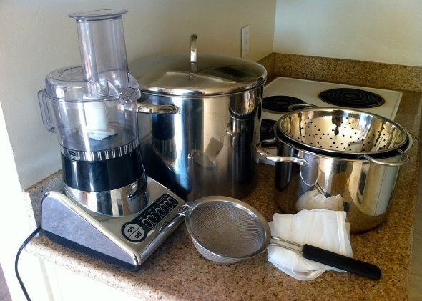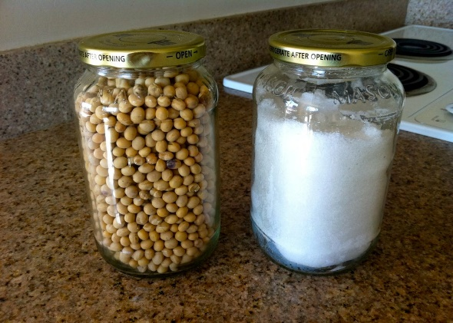

***Ingredients:*** 1 kg of dried soybean, water, 14 g calsium chroride, 20 g salt.

***Equipment:*** Food processor or blender, 2 large pots, 1 colander, 1 strainer, and a few layers of cheesecloth.

**Step 2: Soak and Blend**

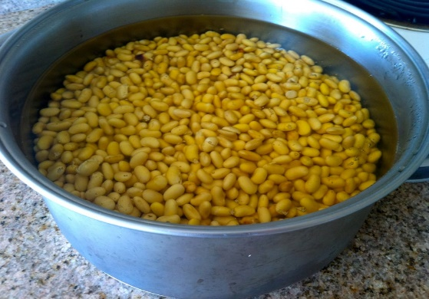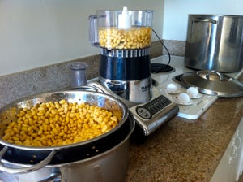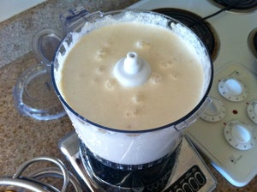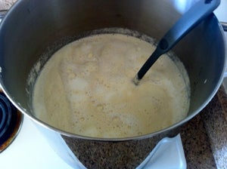

Soak 1 kg of dry soybean over night (the soybean/water ratio of 1:3). Rinse the soaked beans and discard any discolored ones if you spot any. Blend a little at a time with enough water to cover the beans (the soybean/water ratio of 1:5).

**Step 3: Filter out the okara**

**Step 4: Simmer and stir the soy milk**

After grinding, remove the okara to obtain soy milk solution.

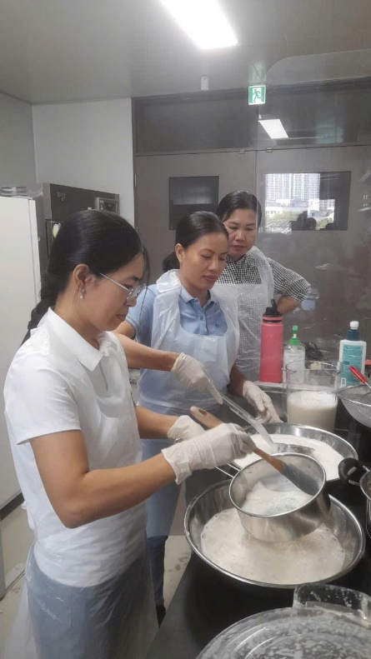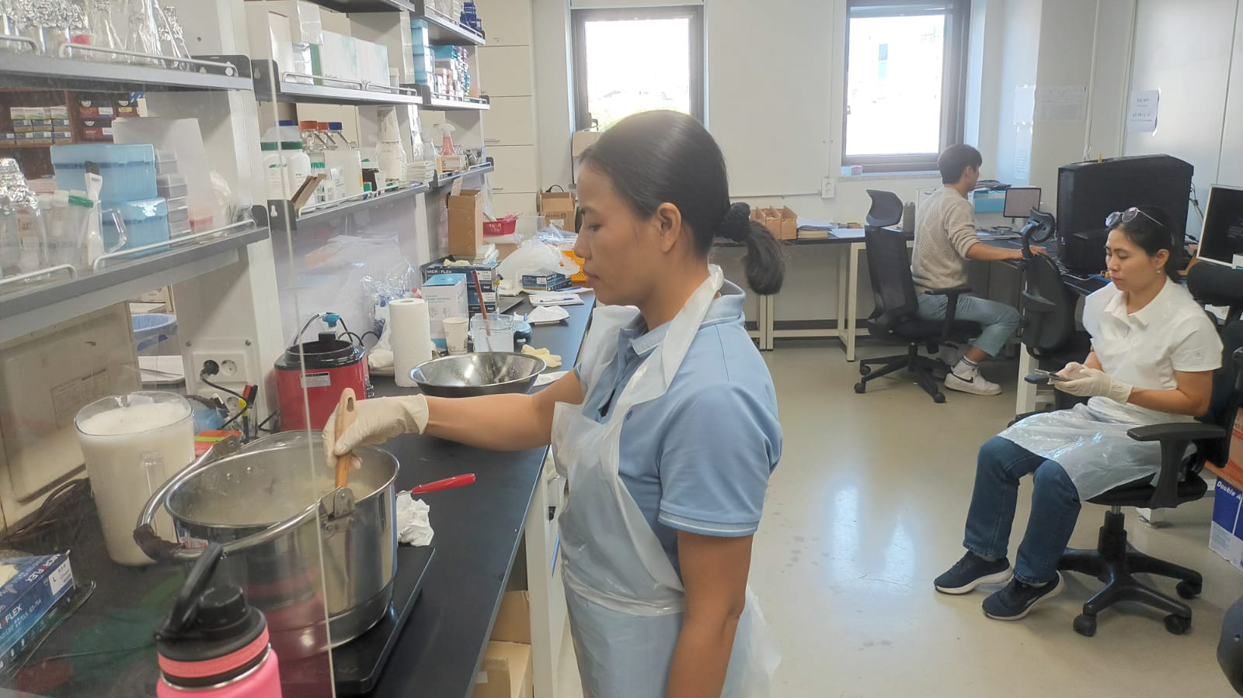

Stir frequently and simmer at 1800C for about 20 minutes. This will foam up a bit so be careful not to let it boil over.

**Step 5: Coagulate**

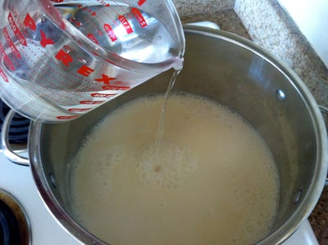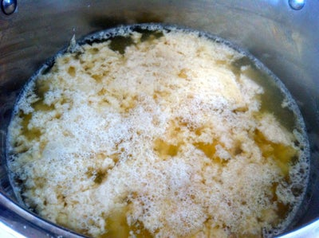

Dissolve 14 g calsium chroride and 20 g salt in 1 and 1/2 cups of warm water. Remove from heat and gently stir together. In about 5 - 10 minutes the curds will separate.

**Step 6: Add to Mold and Finish**

The colander with a cheesecloth makes an excellent mold. Skim out curds and pour into mold. Press down with a small plate and heavy object. Leave for about 5 minutes. After molding, we get a nice slab of tofu.

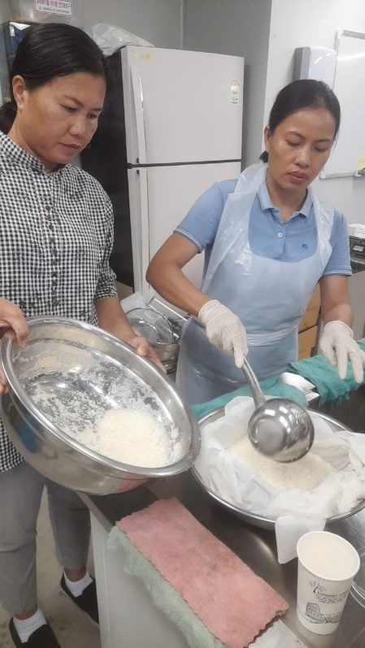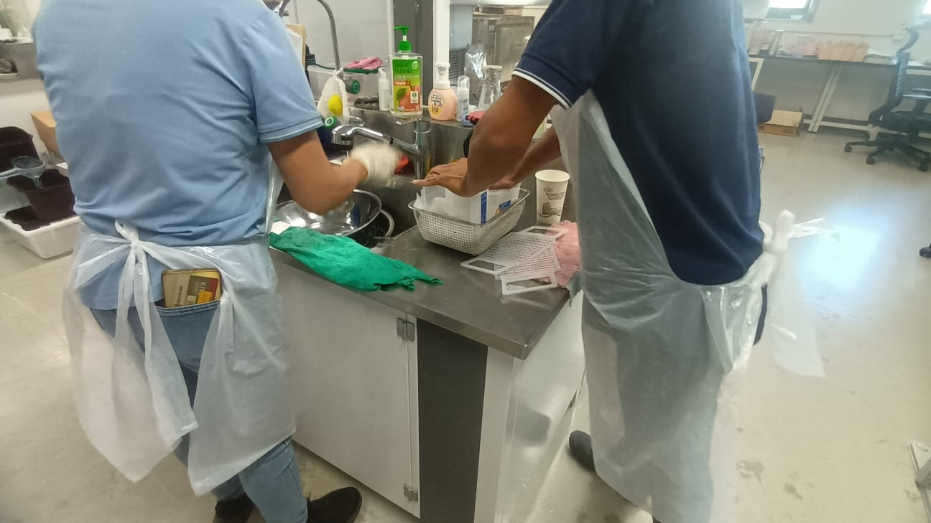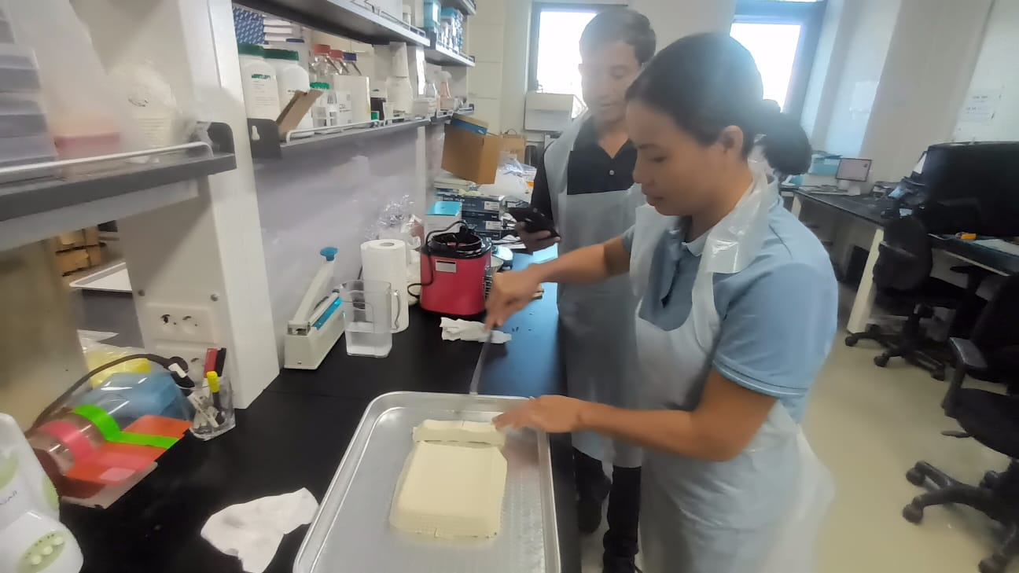

**APPENDIX 3. NATTO PROCESS**

Natto is a traditional Korean dish made from fermented soybeans that's known for its pungent smell and strong flavor. It's often served with rice and mixed with egg as a breakfast dish, though it's sometimes topped with soy sauce…. Making natto is a time-consuming process, though the hands-on time only amounts to about an hour so you just need a little patience to enjoy this Korean delicacy.

**Ingredients:**

* 4 cups (800 g) soybeans
* Water for soaking
* 2 teaspoons (10 ml) water, boiled
* 1 spoonful Nattomoto powder

**Step 1. Soaking the beans**

***Wash the soybeans:*** Place the beans in a colander or strainer, and rinse them thoroughly under cold water in the sink. Shake the beans well afterward to remove the excess moisture. As you rinse the soybeans, remove any shrunken or discolored beans.

***Soak the beans overnight:*** After rinsing the soybeans, place them in a large pot. Cover the beans with cold water to create a ratio of 3 parts water to 1 part beans so the beans have room to expand. Allow the beans to soak for 9 to 12 hours. During colder months, the bean is needed to soak longer, so it may take as many as 15 to 20 hours.

***Drain the beans:*** When the beans have been finished soaking, dump them into a colander or strainer. Shake well to remove all of the excess moisture.

**Step 2. Cooking the beans**

***Transfer the beans to a large pot:*** Once the beans are drained, place them in a large pot. Use a stainless steel, enameled, or other non-reactive pot because reactive materials may alter the taste and color of the natto.

***Cover the beans with water and cook them until they’re soft:*** Pour enough water into the pot to completely cover the beans. Place the pot on the stove, and bring it to a boil over high heat. Once it’s boiling, turn the heat down to medium and allow the beans to simmer for 2 hours.

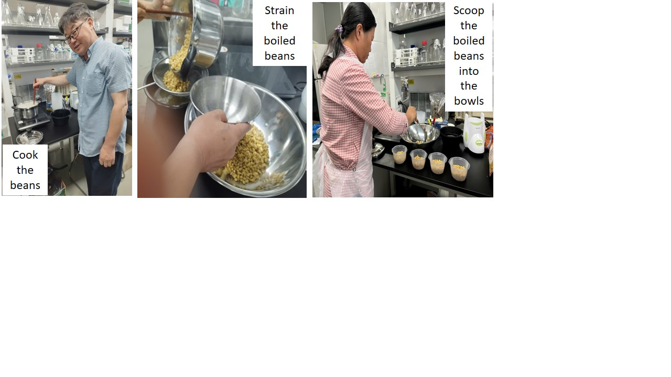***Strain the beans:*** When the soybeans are finished cooking, place a colander or strainer in the sink. Pour the beans into the colander and shake well to remove all of the excess water.

**Step 3. Combining the Beans and Nattomoto Powder**

Dissolve nattomoto powder which contains natto spores in warm water. Spray this solution on the surface of bean bowls. Cover the bowls with foil and make some tiny holes of foil. And then incubate the covered bowls in oven at 380C to ferment. After 24 hours, natto product will be finished. When the beans are finished fermenting, let natto bowls cool for at least 2 hours. And place them in the frigde. Let them chill at least overnight or up to 3 or 4 days. Natto is often served as part of Korean meals. It can also be incorporated into the meals in other interesting ways.

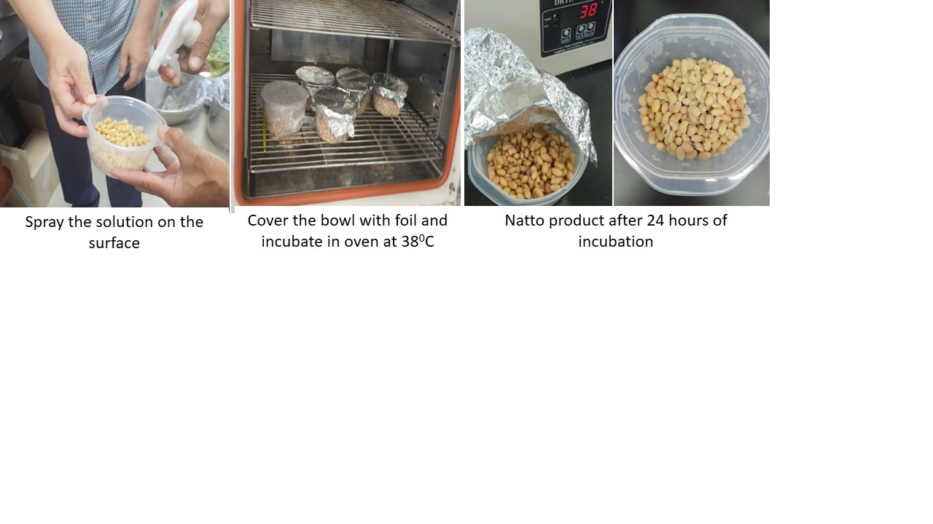

**APPENDIX 4. SOYBEAN PRODUCTS IN THE WORLD**

**1. The products are made by fermented processing.**

***1.1. The Tempeh (Indonesia traditional food)***

|  |  |  |  |
| --- | --- | --- | --- |
| Tempeh - tương nén là gì? Cách làm tempeh bằng lò nướng đơn giản dễ làm | 6 công thức tuyệt vời món chay Tempeh - Hapi Vegan | Vegan Club Sandwiches | Tempeh recipes |
| *Tempeh* | *The dishes are made from tempeh* | | |

**Tempeh processing diagram**

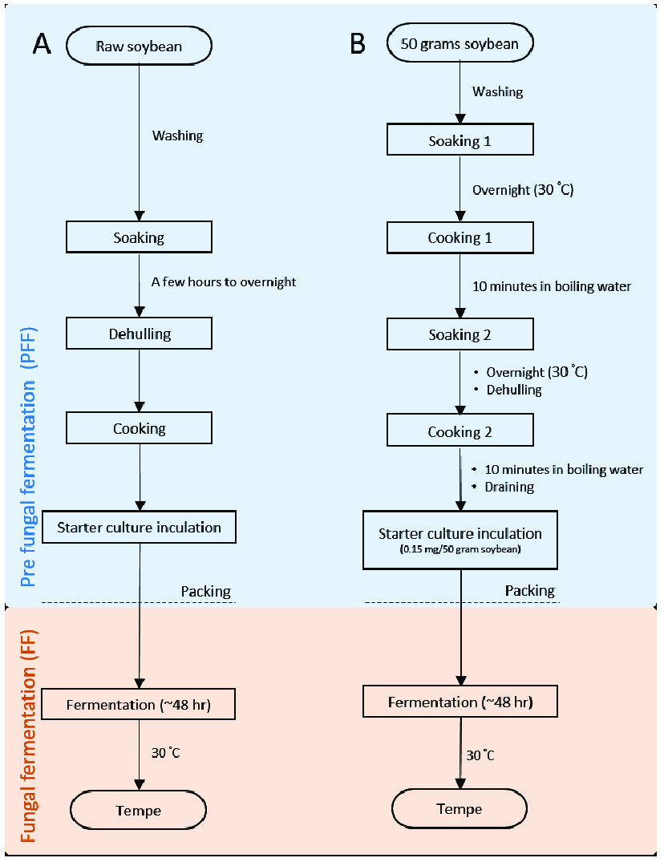

***1.2. Soybean paste (Miso)***

***Homemade Miso***

|  |  |  |  |
| --- | --- | --- | --- |
| Bowl of soybeans after soaking | https://cdn.tgdd.vn/2021/01/CookRecipe/GalleryStep/nau-mem-dau-1.jpg | Cách làm Miso truyền thống đầy thú vị của người Nhật | Bước 4 Chuẩn bị men Tương miso |
| Soaking soybean | Steaming soybean | Crushing soybean | Mixing Koji and salt |
| Bước 5 Trộn đậu và tạo hình Tương miso | Bước 6 Ủ tương Tương miso | Bước 6 Ủ tương Tương miso | https://cdn.tgdd.vn/2021/01/CookRecipe/GalleryStep/thanh-pham-262.jpg |
| Mixing crushed and Koji | Fermantation and maturation in jar | | Miso |

**How to produce Miso in the factory**

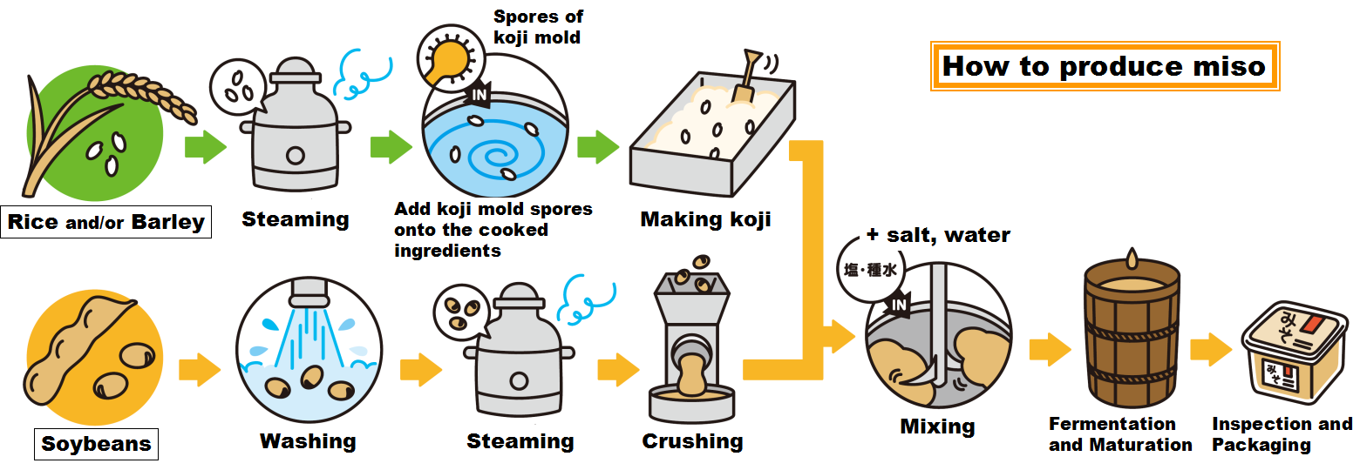 ***1.3. The soybean sauces***

|  |  |  |
| --- | --- | --- |
| Soy sauce | Hình của món Cá hồi sốt nước tương. | A picture of Chef's Nitra Spicy 🔥 Chicken Beet. |

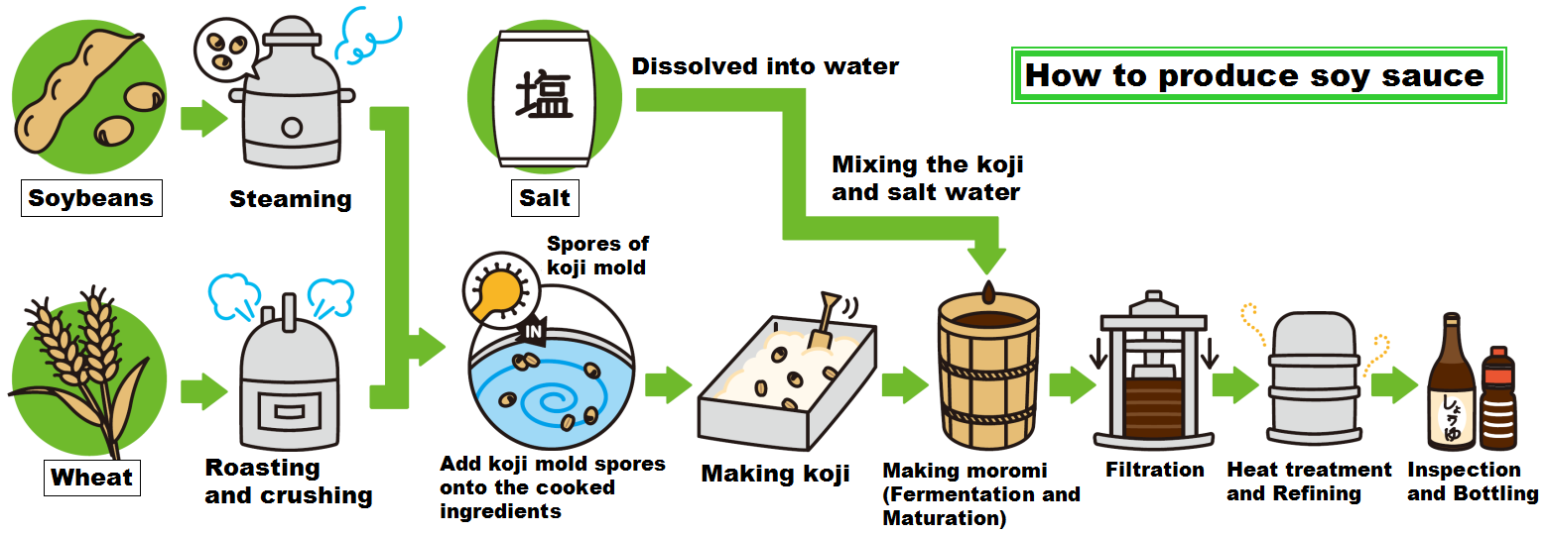

**Soy Sauce Manufacturing Process**

***- Cooking ingredients***

*+* Soybeans are steamed + Wheat is roasted and crushed

+ Add koji mold spores onto the cooked ingredients. + Salt is dissolved into water

***- Making Koji***

Koji mold is added to the mixed soybeans and wheat, and then incubated for three days to make koji. The word “koji” means soybeans and wheat with their surface covered with koji mold.

***- Making Moromi***

Koji is mixed with salt water. This mixture is called “Moromi”.

Moromi is then transferred to a fermentation tank

***- Fermentation and Maturation***

Moromi is slowly fermented and matured for a period of six months. Koji enzymes, yeast and lactic acid bacteria act in this process and create various tastes and flavors.

- ***Filtration***

After fermentation and maturation, moromi is wrapped one by one with cloths and they are stacked into many layers. Then they are slowly compressed and the moromi is filtered through the cloths. In this way, raw soy sauce liquid called “Kiage” is obtained from the moromi.

***- Heat treatment and Refining***

Raw soy sauce is heat-treated for sterilization and then refined. The color, aroma and flavor of soy sauce are further enhanced during this process.

***- Inspection and bottling***

After the inspection, soy sauce is filled into glass or plastic bottles.

***1.4. Natto***

|  |  |  |  |
| --- | --- | --- | --- |
| https://okonomikitchen.com/wp-content/uploads/2021/05/how-to-make-natto-1-of-2-683x1024.jpg | natto curry in a shallow curry bowl | https://www.okonomikitchen.com/wp-content/uploads/2024/06/natto-salad-3.jpg | https://okonomikitchen.com/wp-content/uploads/2021/05/natto-jiru-1-1-of-1-683x1024.jpg |
| **Natto** | **Natto curry** | **Natto salad** | **Natto Jiru** |

***1.5. Vietnamese traditional soya sauces***

|  |  |  |  |
| --- | --- | --- | --- |
| ***Tương bần thực dưỡng*** | Hình của món Cá trắm kho tương bần. | https://bizweb.dktcdn.net/thumb/grande/100/400/508/files/tuong-ban-la-gi-cach-che-bien-tuong-ban-ngon-nhat-3-4d769497-7970-438c-a6a7-8d0e6b8a9b39.png?v=1715827418465 | https://file1.dangcongsan.vn/data/0/images/2023/11/14/upload_2674/tuong-lang-ban.jpg?dpi=150&quality=100&w=800 |
| Tương  (Vietnam traditional soy sauces) | Fish and pork braised in Tương | Tương in daily meals | Tương in jar |

***- Ingredients and tools:***

+ Soybean + Sticky rice + Earthenware jar + bamboo basket

+ Salt  ***+*** Aspergillus oryzae mold + Cloth screen + nylon screen

***- Process of making Tương (Vietnamese traditional soya sauces)***

*Step 1: Making soy sauce mold*

|  |  |  |  |
| --- | --- | --- | --- |
| Bước 1 Làm mốc tương Tương bần | https://cdn.tgdd.vn/2021/02/CookRecipe/GalleryStep/cach-lam-tuong-ban-ngon-dam-da-chuan-vi-hung-yen-tai-nha-6.jpg | https://cdn.tgdd.vn/2021/02/CookRecipe/GalleryStep/cach-lam-tuong-ban-ngon-dam-da-chuan-vi-hung-yen-tai-nha-4.jpg | https://cdn.tgdd.vn/2021/02/CookRecipe/GalleryStep/cach-lam-tuong-ban-ngon-dam-da-chuan-vi-hung-yen-tai-nha-5.jpg |
| Washing and then soaking sticky rice in 4 hours | Steaming in 30-40 minutes | - Place sticky rice on a large tray, spread it thinly to cools quickly  - Add Asperigillus oryzae mold on sticky rice, then incubated for few days until it turns yellow with the fungus | |

*Step 2: Soak, roasted and grind soybeans.*

|  |  |  |
| --- | --- | --- |
| Bowl of soybeans after soaking |  | https://cdn.tgdd.vn/2021/02/CookRecipe/GalleryStep/chuan-bi-do-tuong-1.jpg |
| Soybeans are soaked in water and dried | The soybeans are then roasted with sand in thick pan at low temperature till they turn brown with a sweet smell. | Grind roasted soybean until just crushed (not pureed) |

*Step 3: Fermented process.*

|  |  |  |  |
| --- | --- | --- | --- |
| Bước 3 Ngả tương Tương bần | Bước 3 Ngả tương Tương bần | Bước 3 Ngả tương Tương bần | Chú thích ảnh |
| Put crushed soybeans and water in earthenware jar to soaked again for 9 days.  - Stir in one direction for 5-7 minutes - one time per day. | - Added the fungus and salt and stir evenly  - For the next 3-5 days, stir for 5-7 minutes each day to mix fungus and crushes soybean evenly.  - Covered tightly and dried in the sun for between two – six months.  - During the drying period, should stir the mixture every two days at 10.00 am, but just for minute. | | The final product |

**2. Non-fermented soybean products:**

***- Soybean sprouts***

|  |  |  |
| --- | --- | --- |
| https://img.meta.com.vn/Data/image/2019/11/05/cach-lam-gia-dau-nanh-3.jpg | https://www.soba.com.vn/assets/images/products/gia-tron-dau-vung-panchan.jpg | https://www.soba.com.vn/assets/images/products/canh-kim-chi-gia.jpg |

***- Soymilk and Tofu***

|  |  |
| --- | --- |
| IMG-20240907-WA0060 | IMG-20240907-WA0091 |

***- Protein bars***

***-*** ***Fortifield cereals.***

**3.** **Soy ingredients include textured soy protein, soy protein isolate, soy protein concentrate, soy flour, lecithin, and soybean oil.**

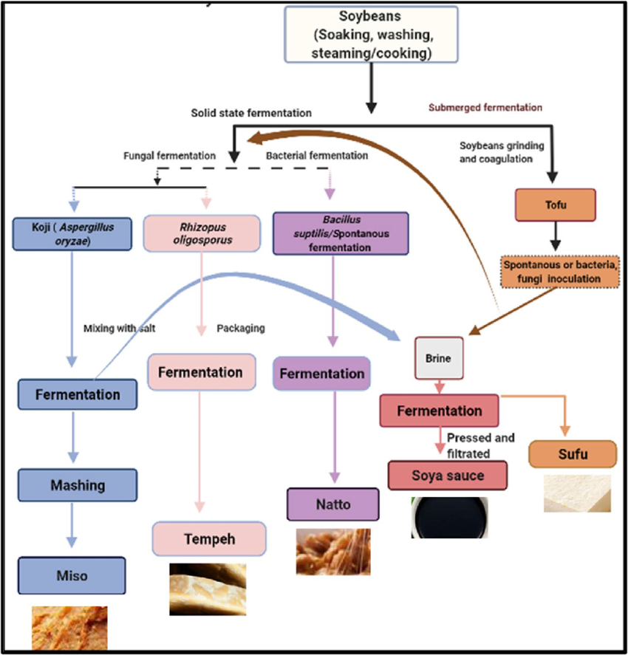

**APPENDIX 5. PROTOCOL OF MAKING TOFU PROCESSED PRODUCTS**

|  |  |
| --- | --- |
| **Ingredients & Tools** | **1. Korean style Tofu Cookies**  ***\* Ingredients:*** 2 eggs, 140g white sugar, 140g drained tofu, 360g cake flour, 20g canola oil (or vegetable oil), a small amount of valina essence (or vanilla oi), 4g baking powder, 5g salt, 3 tablespoons black sesame seeds.  ***\* Tools:*** Oven, baking tray, hand mixer, rolling pin, mixing bowl, rubber spatula, ziplock bag  **2. Frozen Tofu crackers**  ***\* Ingredients:*** frozen tofu, herb salt, oil  ***\* Tools:*** oven, baking tray, knife, cutting board |
| **Methods** | **1. Korean style Tofu Cookies**   1. Allow the tofu and eggs to sit at room temperature for 1 hour. Drain the tofu thoroughly using a cheesecloth or a clean kitchen towel. 2. Measure the cake flour, salt, and baking powder, then sift them together. 3. In a mixing bowl, beat the room temperature eggs using a whisk. 4. Add the sugar and vanilla essence to the eggs and mix well. 5. Add the drained tofu and black sesame seeds to the egg and sugar mixture. 6. Gradually combine the sifted dry ingredients with the egg mixture.   Be careful not to overmix, as this can cause gleten to form, making the cookies too elastic. Use a spatula to mix in a gentle “# (number sign)” pattern.   1. Once the dough comes together, gather it into a ball, place it in a ziplock bag, and roll it out to a thickness of 0.3-0.5cm. Let the dough rest in the refrigerator for 30 minutes to 1 hour. 2. Preheat the oven to 1800C. Transfer the dough to a baking tray, and use a roller or fork to create docking holes in the dough. 3. Bake for 13-15 minutes at 1800C. 4. Let the cookies cool before eating.   **2. Frozen Tofu crackers**   1. Submerge the tofu in water in a container and freeze it in the freezer. 2. Once the tofu is slightly frozen, slice it thinly using a knife. 3. Drain the tofu thoroughly and season with herb salt and oil. 4. Preheat the oven to 1800C. Bake for 10 minutes, flipping the tofu halfway through at the 5 minutes mark. 5. Let the crackers cool before serving. |